**Adult ESL Level 2 Textbooks**

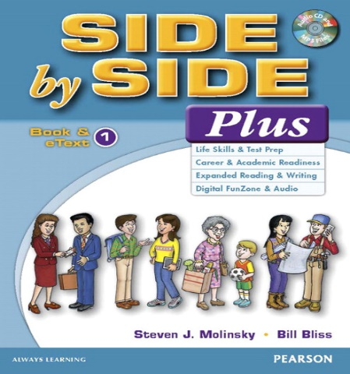 **This will be our main textbook with Vocabulary**

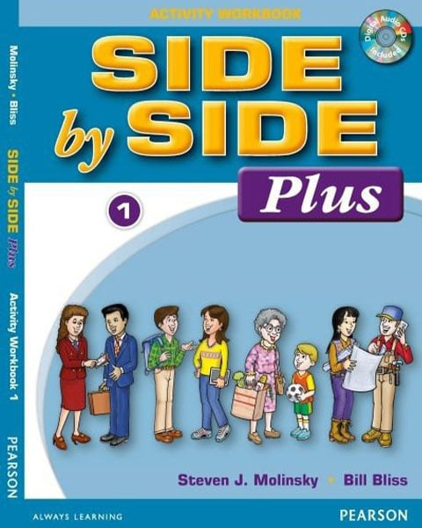 **This will be our main activity textbook**

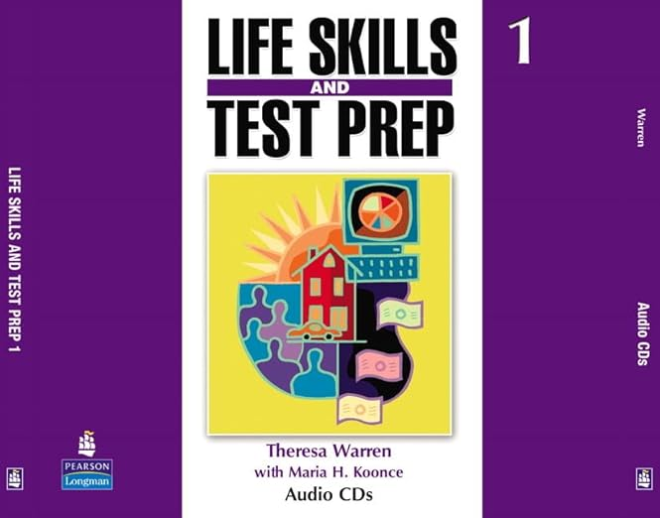 **This will be our Life Skills Test prep textbook**